When first time you create react native application you need to setup react native environment in your OS It does not matter what is your OS the first will be first you setup the environment for react native and then your application will be created and then you can do development and do build there you can make anything
and whatever steps we will follow to setup environment will be from official documents which is given in React native. The reason is that we wil be installing react native in an official way.
Second reason is that by chance if you come across some 1 – 2 percent problems then you can check the official documents you can resolve it
So first we see the major points and then we will see how to install from our official documentation
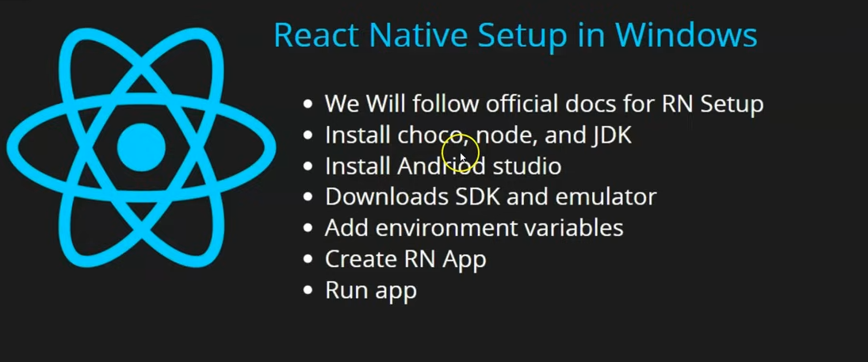
First we will install choco which we call chocoloty node and JDK
We will install Android Studio
Download SDK and Emulator
Then we need to set environment variables for Android Studio
We will create our first React native app and then run our app.
During the lesson we will see some errors during installation which we will see how to resolve it.
If that problem has also occured with you then see how to solve them
Now go to react native official website
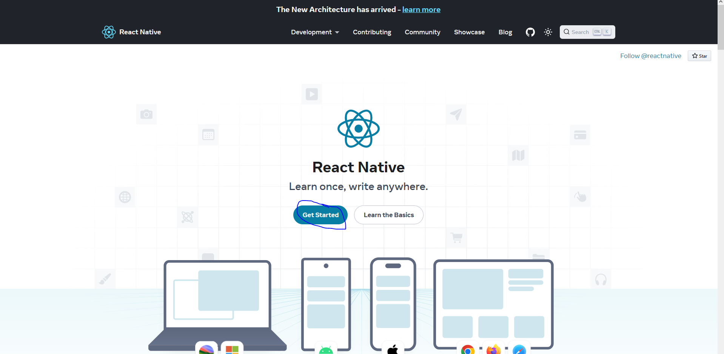
click in Get Started button as marked above
In modern UI I cannot see anything teacher is saying so we will see from Teacher Perspective
after the Get Started button get clicked you will be directed to a new page where you get two option to install React native in your PC.
First is Expo Go Quickstart
and then comes React native CLI quickstart.
The problem with Expo Go Quickstart is that you have to keep your phone to yourself and connect it to wifi (or Connect PC to wifi for internet(who knows))(I think maybe not anymore in modern expo. Now you can use expo in your emulator). You will be developing apps in PC and will run it in the Phone.
It gives weird experience
So we will go to React native CLI quickstart
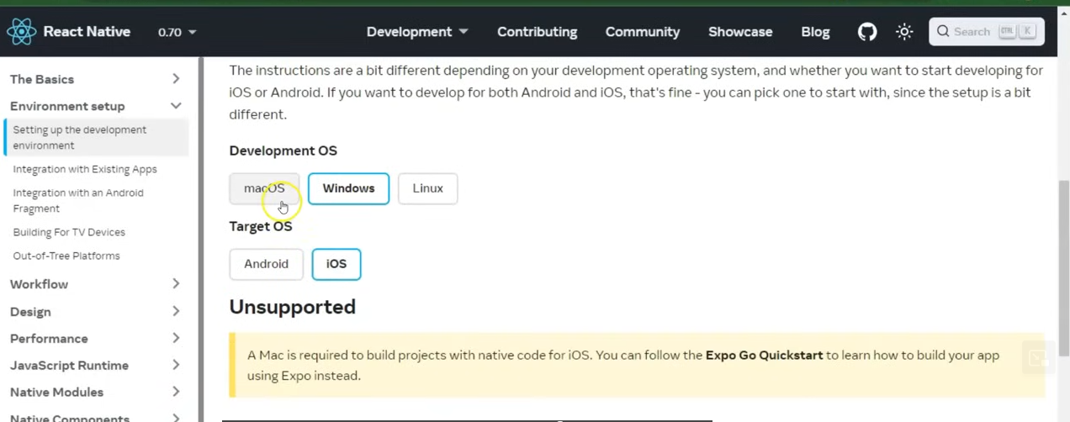
You can only set up environment for IOS only in MacOS.
The problem is that our Window or Linux file(maybe Environment file) cannot compile file for our
IOS(who knows). You can only check Android build with the help of Eindow or linux files
________________________________
Note:-
Maybe in modern UI Documantion by default follows CLI installation method
________________________________
So now if we move forwards It will say to install Node and JDK
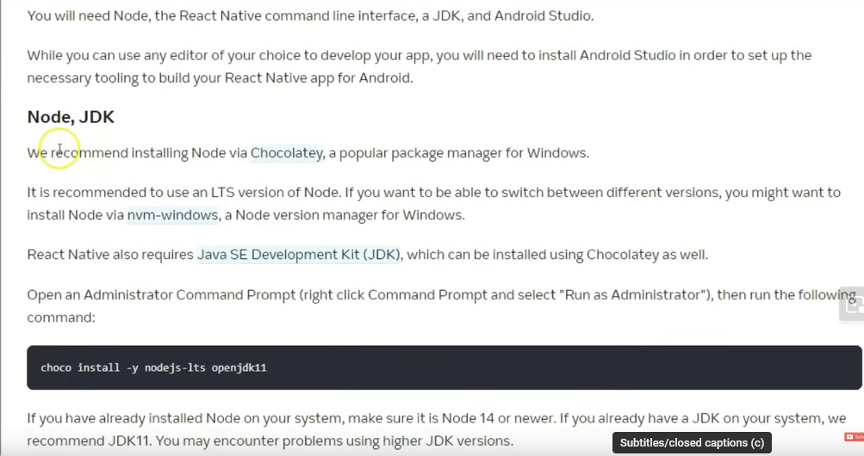
and for that doc recommend installing Node and JDK via chocolaty which is a package manager for windows.
My UI recommends install JDK 17 if install higher then you may face some errors here.
Chances are still less but we will still go through it according to official documentation
We need to type a cammand and for that we need to install in your PC To do so
Go to link below
https://chocolatey.org/
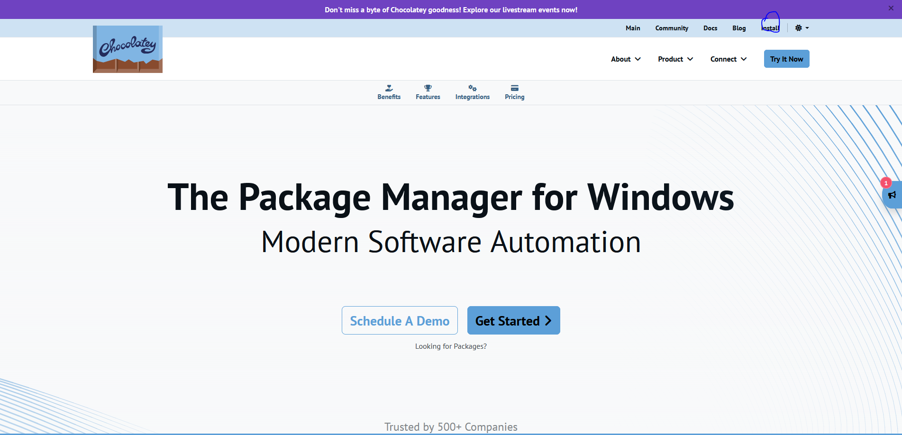
Click on install menu as marked above you will directed to a new page
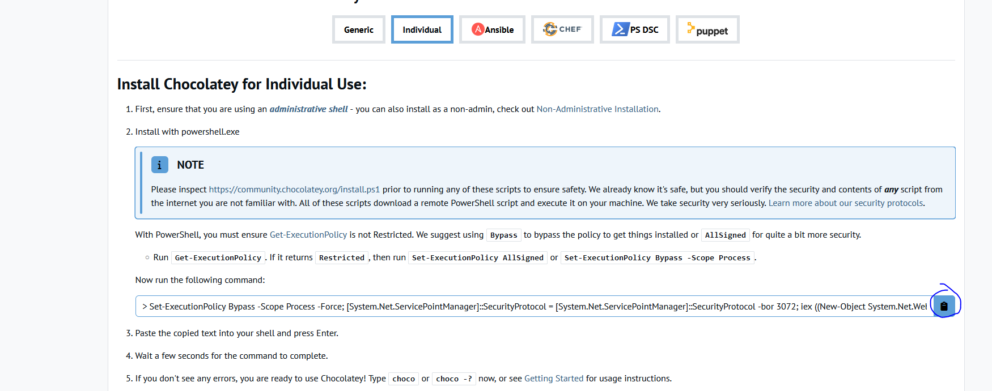
Now copy the code shown in our new page by clicking on the marked above
and run this cammand in our Powershell and open in it as administrator
After it get opened then it will take some then you can type the cammand there
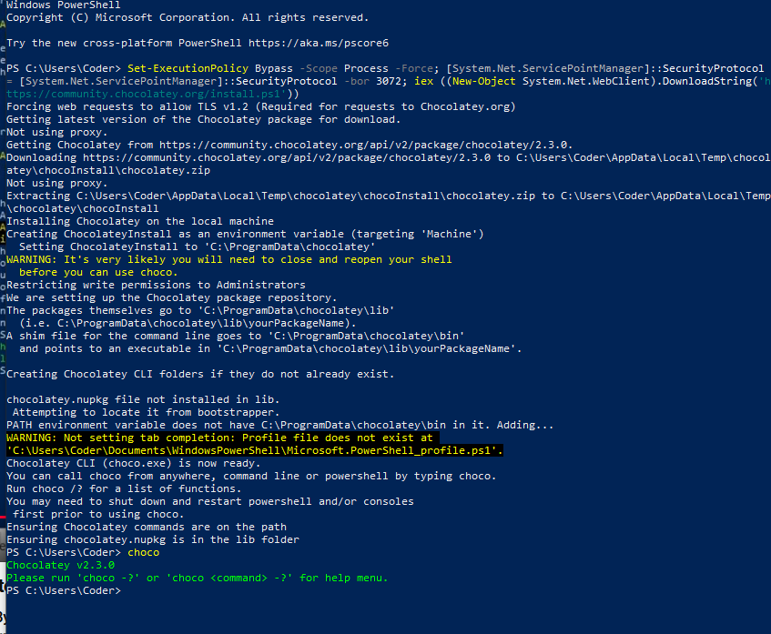
To see that chocolaty is installed in your PC type choco in your cmd or Powershell
then it will show version like below
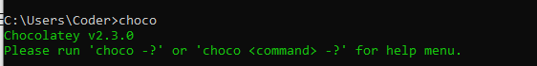
Now we will type this cammand
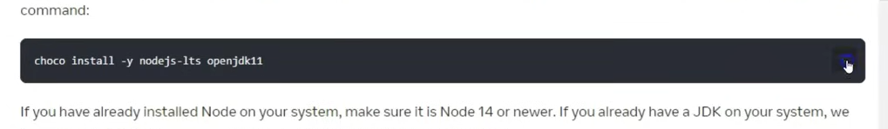
To install our JDK17(because my version of documentation recommend JDK 17 )
If it is already installed it then it will say you have already downloaded and installed it
______________________
Note:-
Always go step by step
______________________
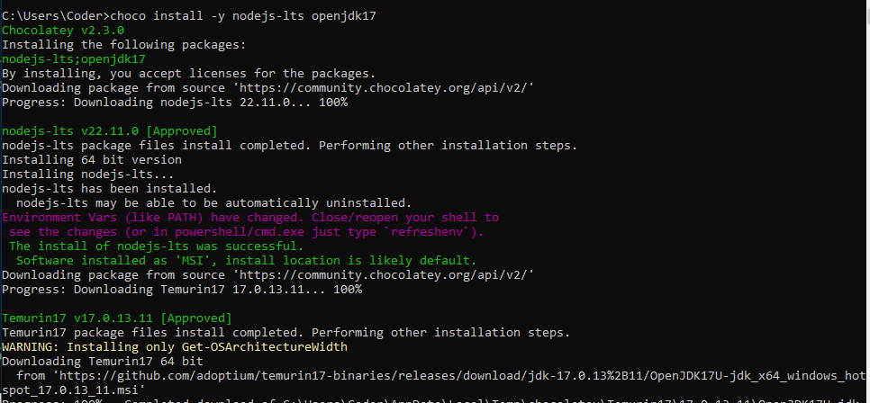
you can now check whether does node exists in your pc or not
by typing node -v
or to check java type cammand java -version
Now download and install Android studio
When it will be installing then by default it will give dependencies (who knows)
Android SDK
Android Virtual Device
Android SDK Platform
check their checkbox during installation and Accept them
They wwill be asked when you run the android Studio first time
If you have 8GB RAM and does not have SSD 3 then it will work slow but if you have it then it will work fine.
In case of slow working you have to adjust your PC.
In Android setup window if it does not find SDK in your PC then it will tell you no Android SDK found
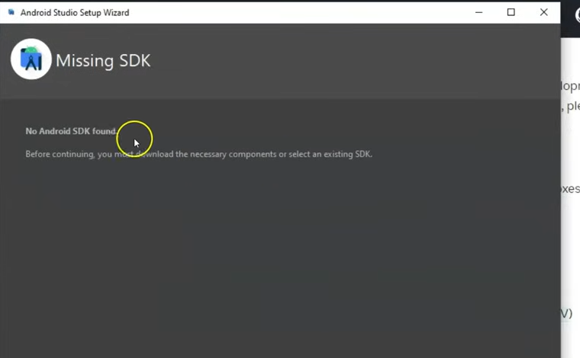
go to next
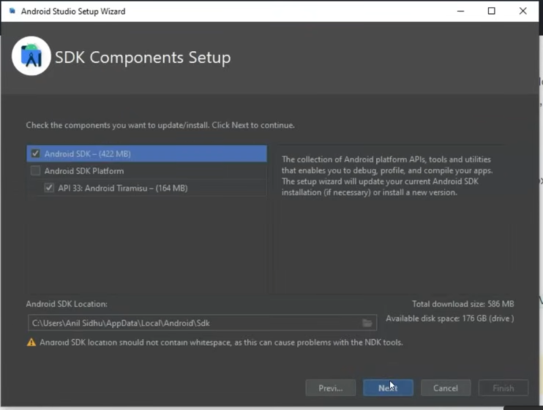
It will suggest you some version of SDK select the SDK you want to install and now click on next button
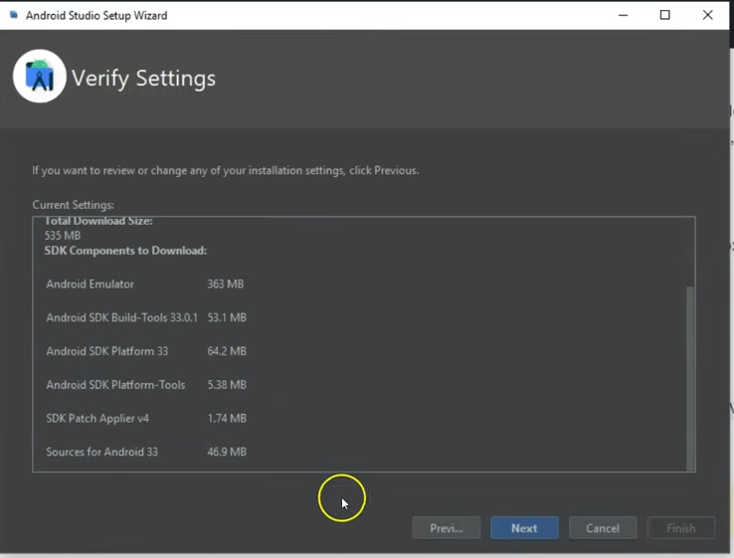
In above it is showing what will be installed click on next button
Teacher will install other things also but for now we will install them
Android studio when opened second time it opens fast beause it take data from cache
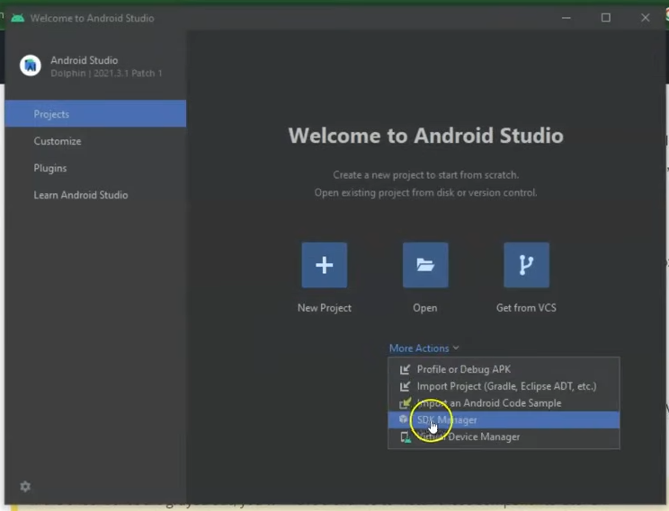
Now when the android studio opened first time it will show a window as shown above
Now click on More Action and a submenu will be shown click on SDK manager \
If your opening it second time then you will not see it so in android Studio window
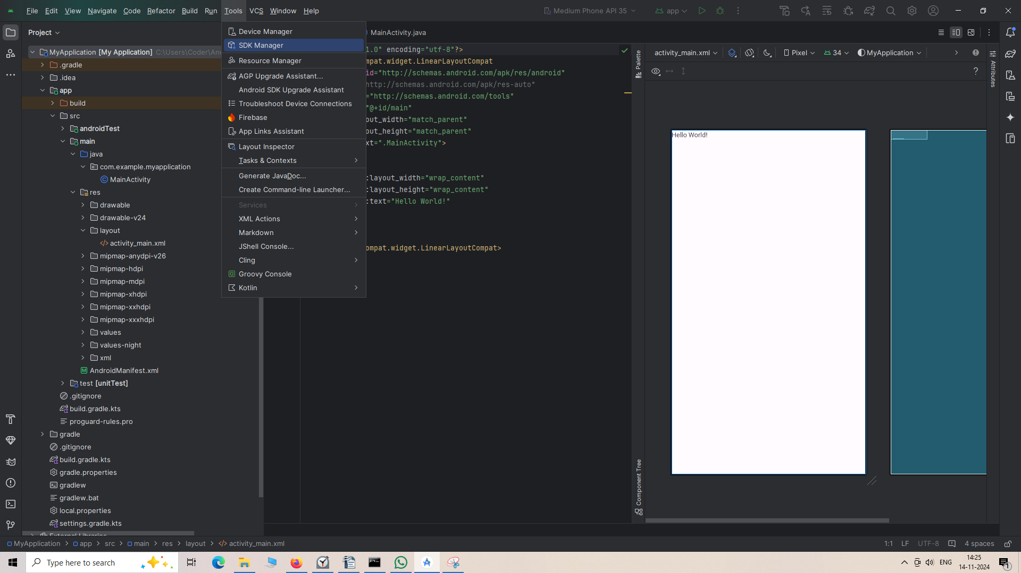
Go to Tools and then to SDK Manager
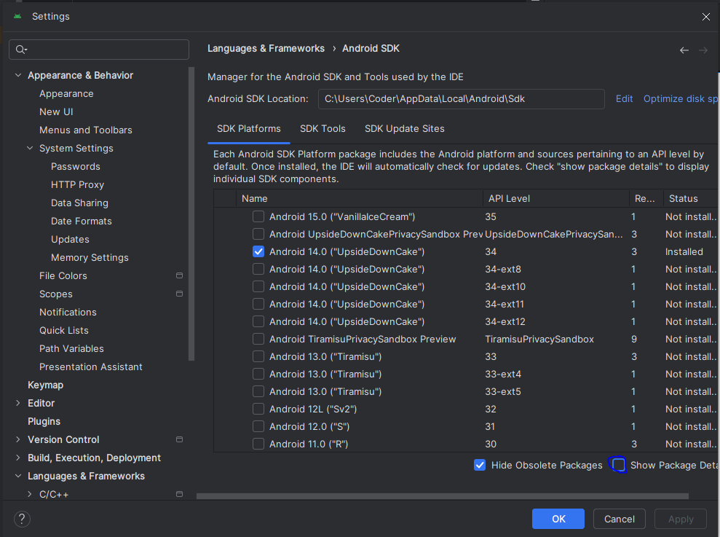
Now check the Show Package Detail checkbox as marked above
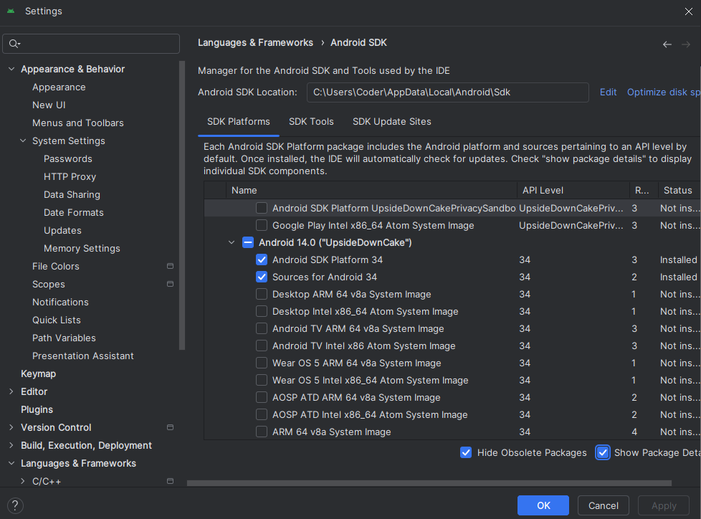
Now every option is expanded now
Now in Android 14 option select the Android SDK platform and Sources for Android 34
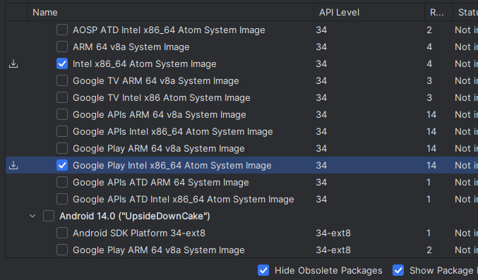
Now check the checkbox
Now go to SDK tools tab.
Here also check Show package details
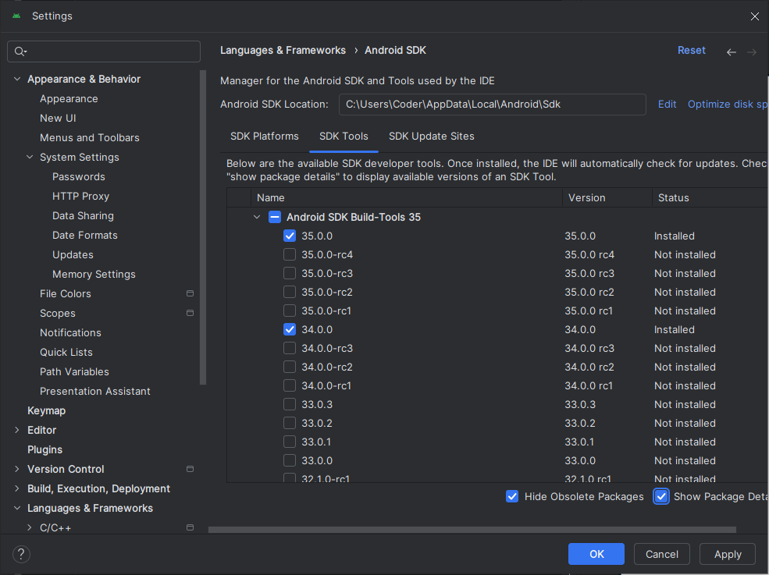
and check 34.0.0 and 35.0.0 is already installed during the Android studio setup when it was opened first time
_____________________________
Note:-
I think that a particular SDK emulator will be installed for a particular set of emulator.
_____________________________
Now the checked component will be installed after few time depending on the speed of your internet. Now you have to set ANDROID_HOME environment variable configuration
Just search the Edit the system environment variables and click on the below highlighted option
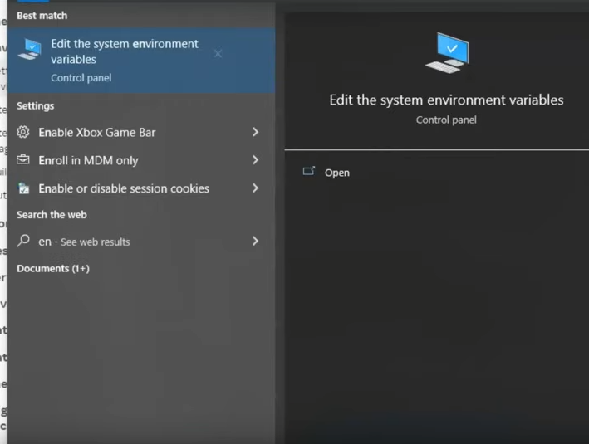
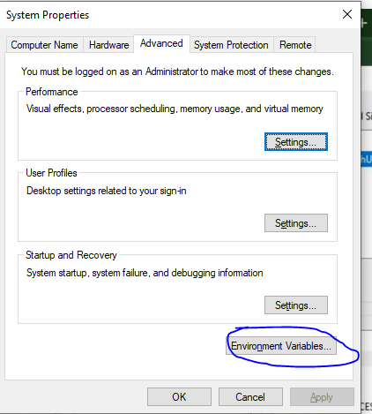
Click on Environment variables as marked above and new window will be opened

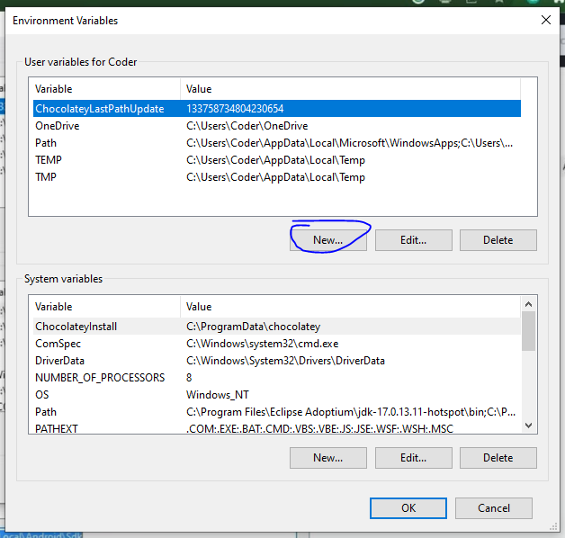
Click on new as marked above to make a new environment variable
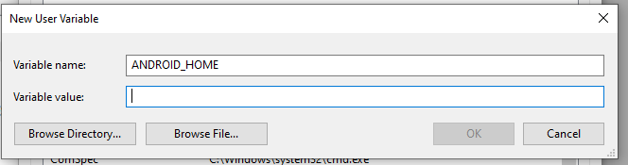
In a variable name you can type ANDROID_HOME (space is counted) In varible value you can type
%LOCALAPPDATA%\Android\Sdk
%LOCALAPPDATA is a placeholder for C:\Users\Coder\AppData\Local But it is not better
Better will be if you write absolute path from C like

C:\Users\Coder\AppData\Local\Android\Sdk
I think above url is for SDK dependency
The Path is towards the SDK in AppData.
Both will work but the latter is better
Now click on OK button
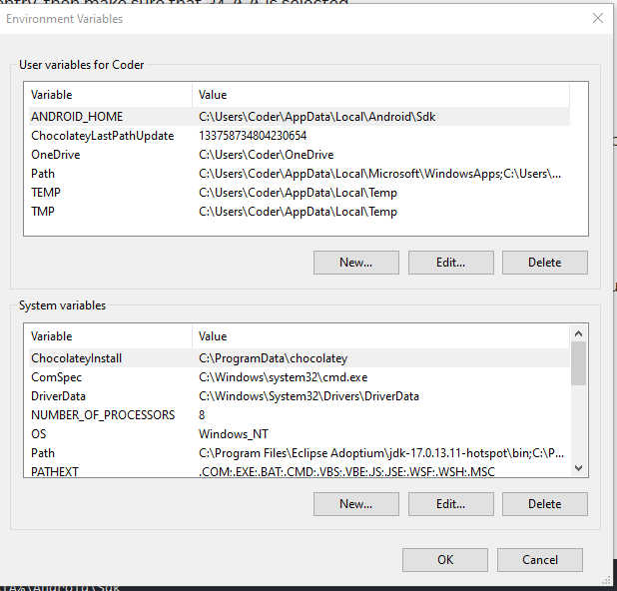
Click on OK button
Now to check that the ANDROID_HOME is configured as a variable
Get-ChildItem -Path Env:\ in Powershell
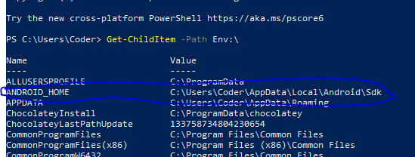
In above you can see the ANDROID_HOME in the liat as marked above
now we need to set
in similarly way add the platformtools to path
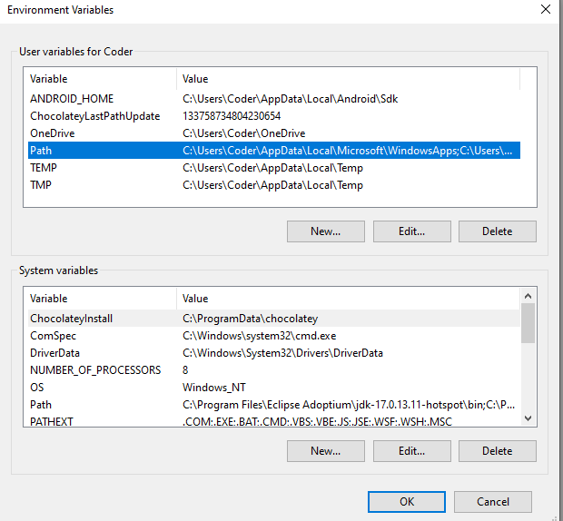
The upper box is only for a particular user
The lower box is for all the user present in PC
So we will add the path of platform tool to the path varible in lower box of system variable
so select the path an then click on edit or double click on it and then a small window
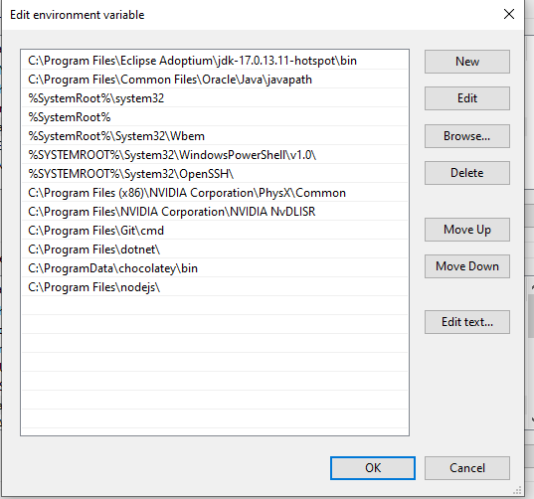
Click on new button and then paste teh path of platformtools in the list No click OK
The path is below

C:\Users\Coder\AppData\Local\Android\Sdk\platform-tools

or you can also use

%LOCALAPPDATA%\Android\Sdk\platform-tools
I think above url point to emulator

Now we will open our virtual device as it is opened by sdk (who knows)
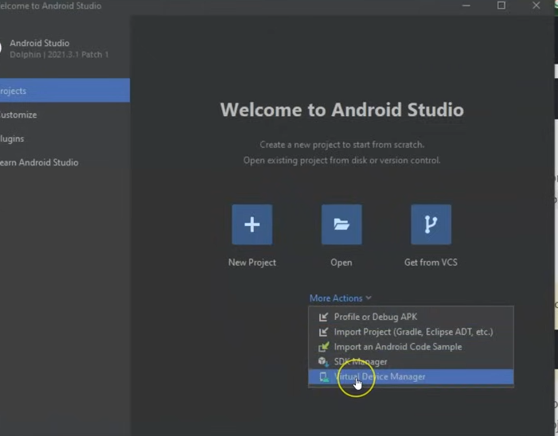
Now click on more acion and then in submenu open Virtual Device Manager
or you can in The Android Studio Manager window go to Tools > Device Manager
It will show you list of avd if you don't have then creative new as we know

Now in Create device configuration

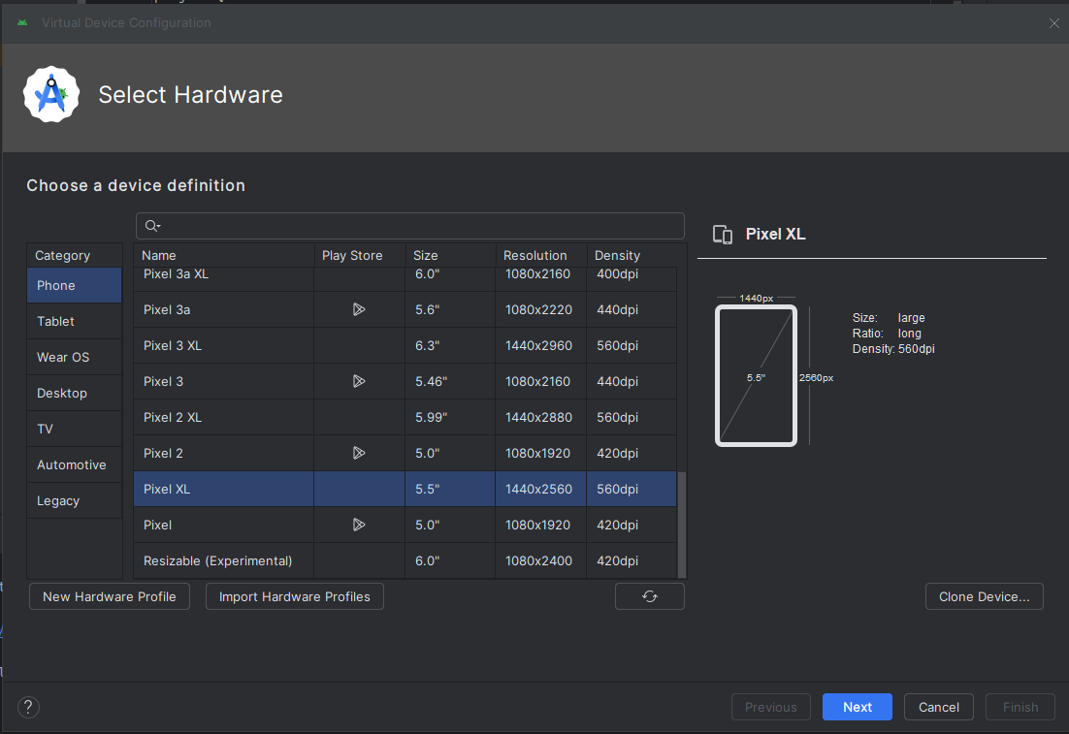
choose your device you want to use
choose Pixel XL under Phone and then click on Next button
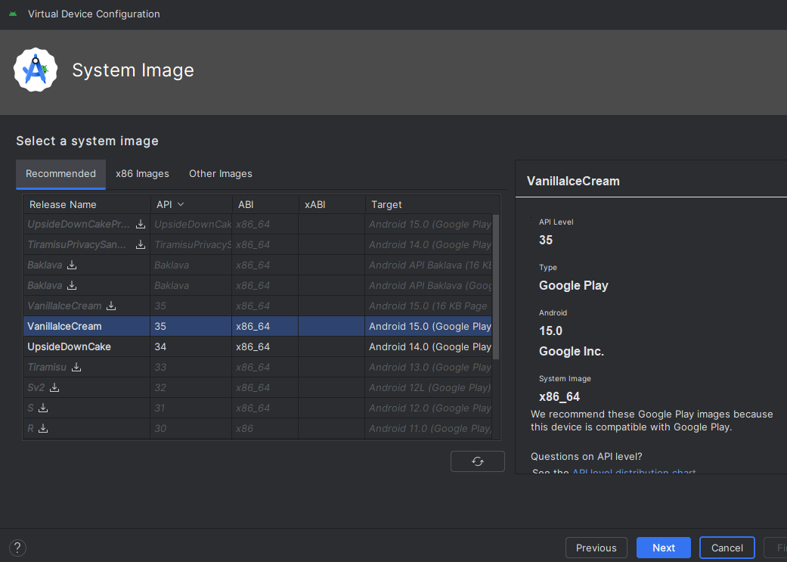
Now in new UI choose the image you want as you can see above API 35 is already installed and 34 is also installed (we installed previously while studying SDK Manager(remember we installed a thing started with google))

Now in new UI type the name you want to keep for AVD Name
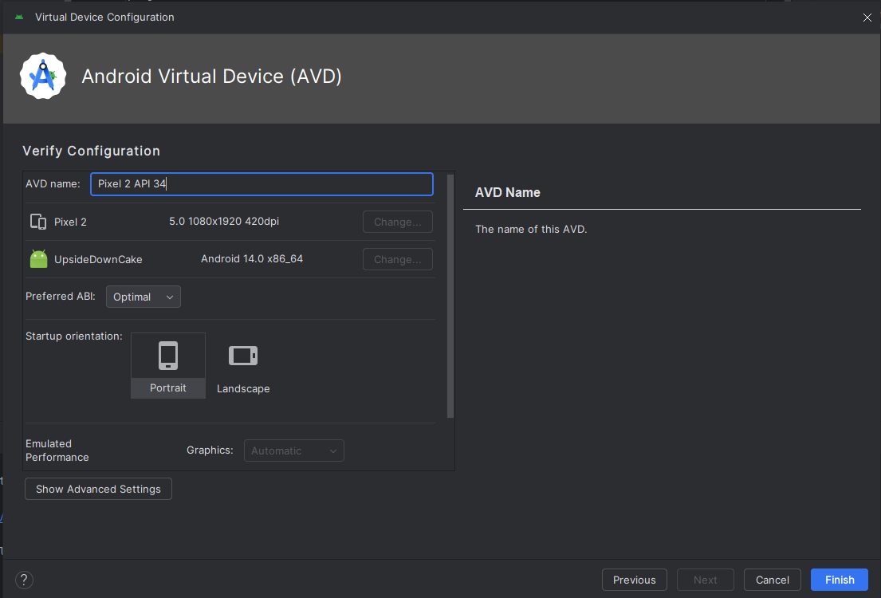
Now you can click on Finish button. You can see our new AVD in our AVD list

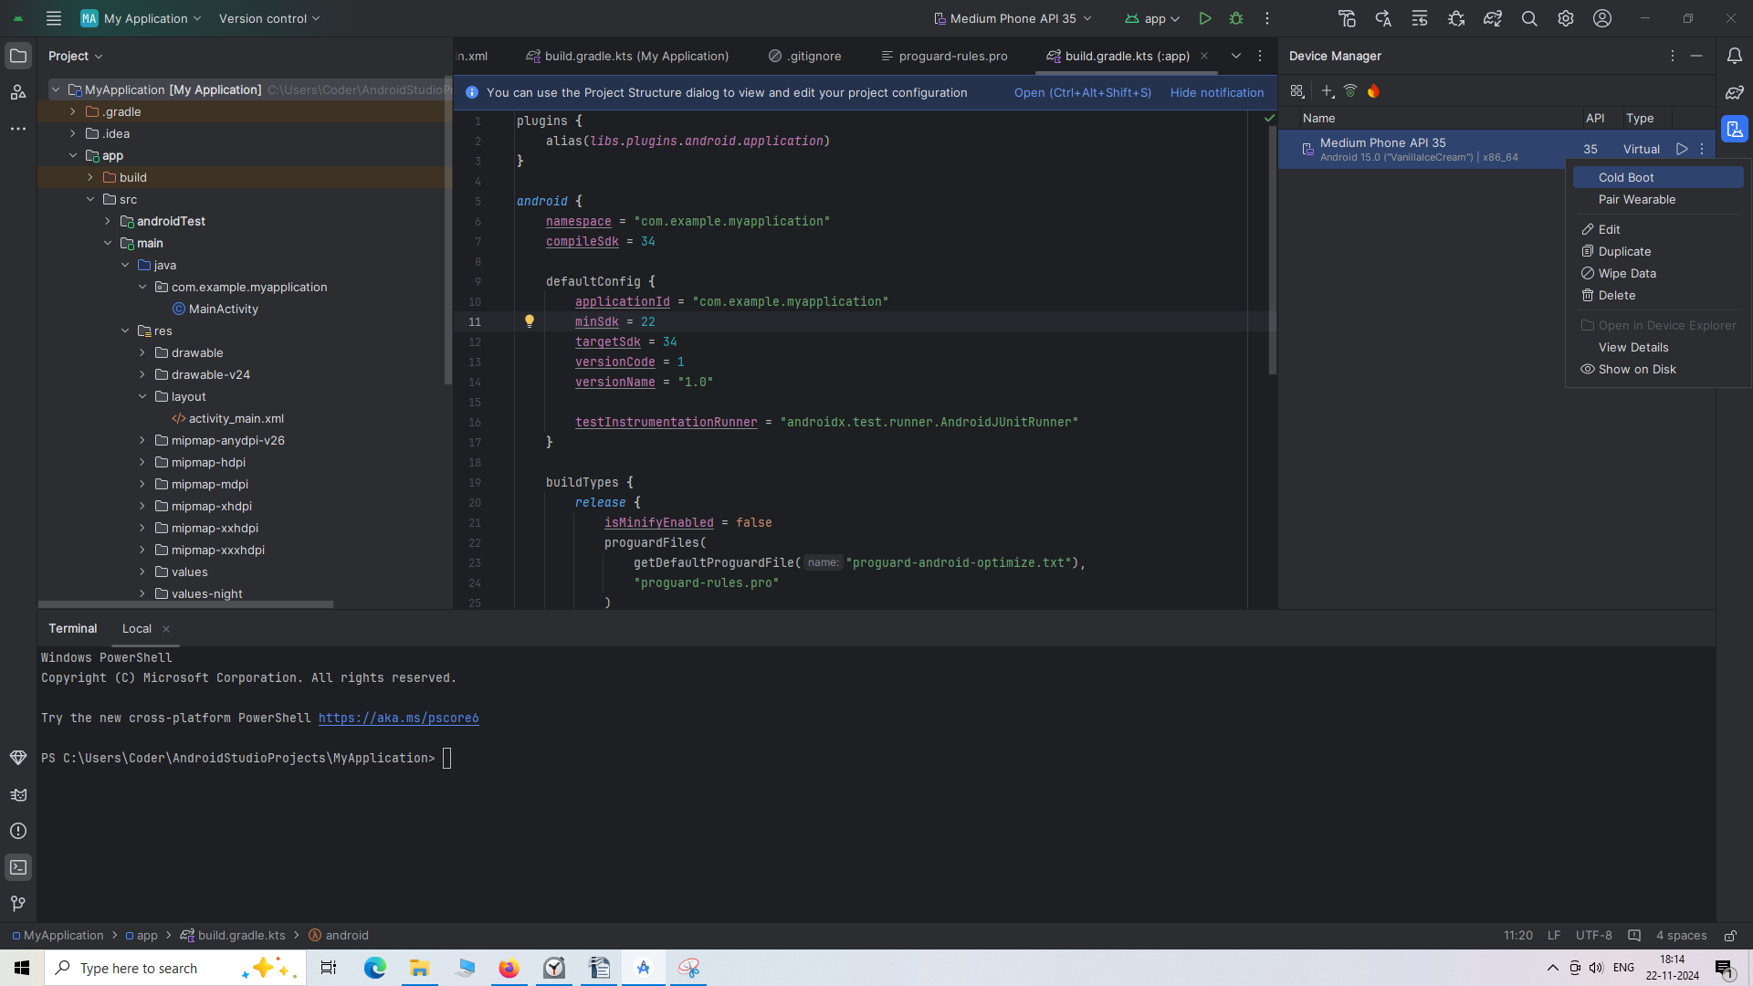
If you click on 3 vertical dot present on the AVD item in the AVD list you get a list of operation to perform as shown above you can duplicate your AVD, you can wipe out its data, you can even delete the AVD.

The Windows Hypervisor Platform (WHP) is a set of APIs and system services that enables hardware virtualization on Windows-based systems. It provides the necessary infrastructure for running virtual machines (VMs) and supporting hypervisor-based technologies within the Windows operating system.

Hyper-V Support
- While Hyper-V is Microsoft’s own hypervisor, the Windows Hypervisor Platform is a more general-purpose layer that allows third-party hypervisors to coexist with Hyper-V. It provides a common set of APIs that can be accessed by virtual machine management tools, including Hyper-V itself.
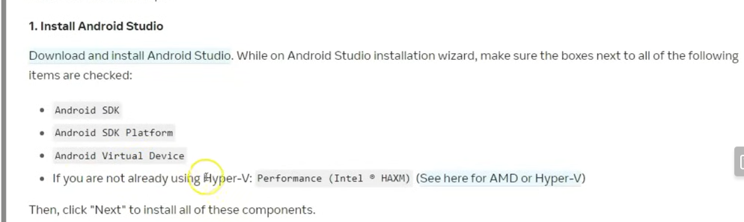
I think that Hyper V and Windows Hypervisor platform give our system API that boost our system experience especially
To know about it more click on the See Here for AMD then you will be directed to a page telling about it and how to activate it in our windows.
So first of all search Turn windows features on or off.
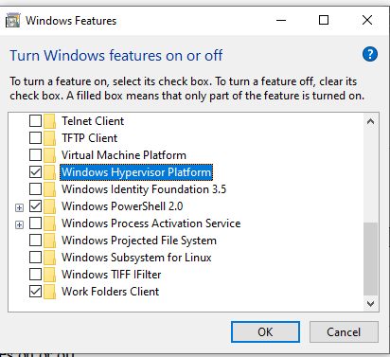
Now a window will be open check the Windows Hypervisor Platforms and It may happen that in place that in place of it Hyper V is written still check it and now click on OK.
And now it will take some time as shown below it also may not take time at all
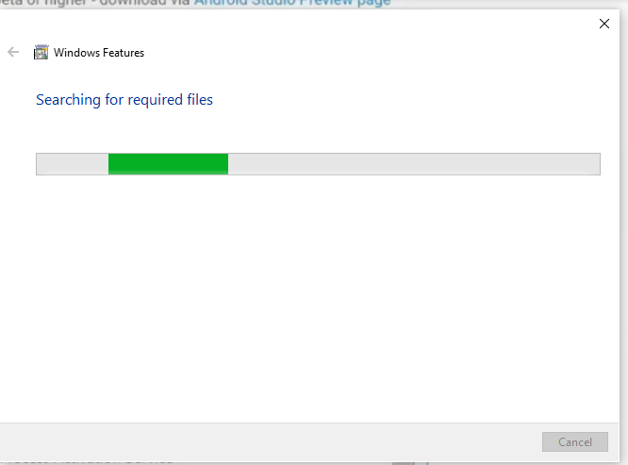
Now to open an emulator as in independent window go to File>Settings and then a new window will open like this
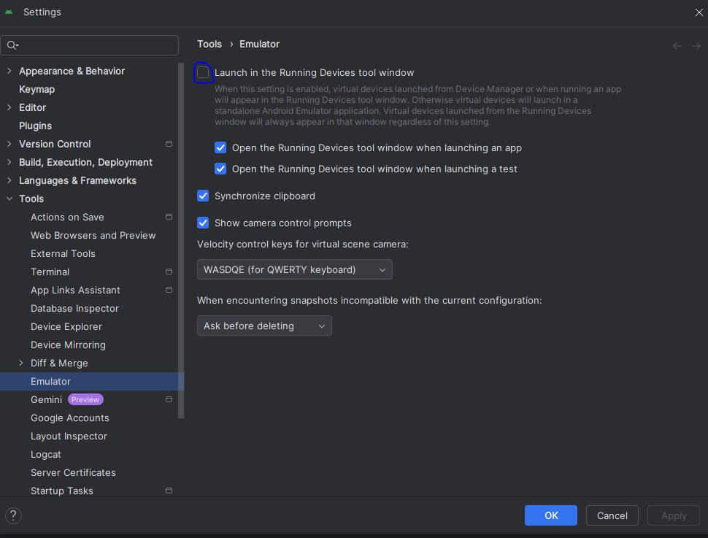
Now uncheck the Marked checkpbox By unchecking it you can avoid launching in the panel of Running devices tool but in a seperate window.
Click on Ok button
you will see your emulator when you run it in a seperate window as shown below
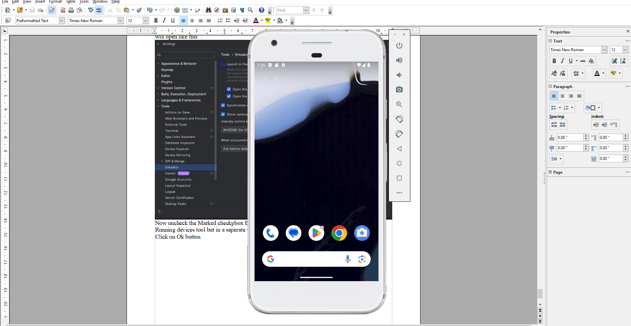
(The above picture is of Android Emulator)
It will work like a physical phone you can use youtube, or any other app here.
Our 50 % workis done but now the things will come which are more prone to errors and can have issues lets see
If in your system there is a global CLI version of React native (i don't know what it is) then uninstall it. Because when you will run cammand of CLI then it will execute the cli cammand from our local computer because npx will first check within the local computer if there is a CLI in our local computer then it will execute it instead of fetching resources of cli from Internet but we want to execute the latest internet cli version so we will uninstall it if present in our local computer(maybe)
Now create a React native project in specific folder where you will keep your react native Projects.
Now use below cammand to create your React native project
Expo

npx create-expo-app@latest
It can happen that you may get some errors here (maybe because we did not follow the the step properly)
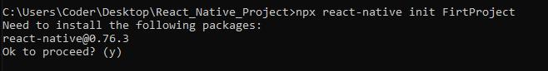
you will get the result above press y and then press enter
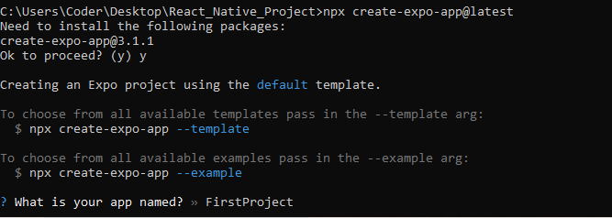
Now in above It will ask you the name of your project
we name it First Project
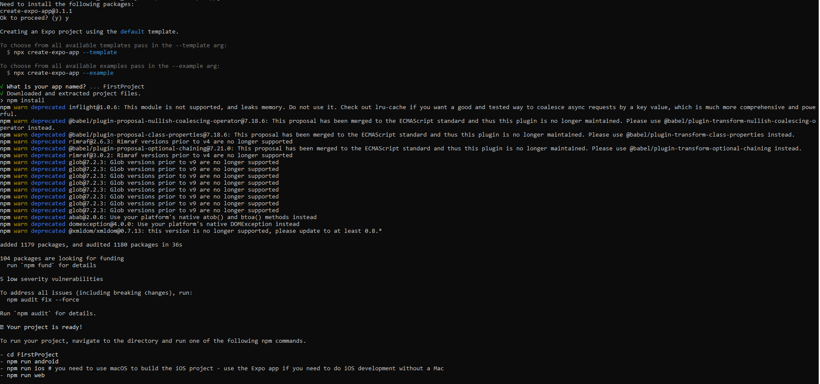
Now go inside the project folder of the same name as your application
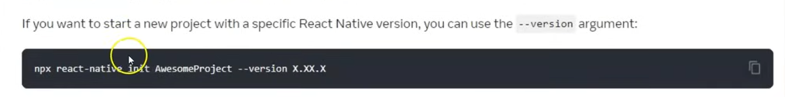
(Old)
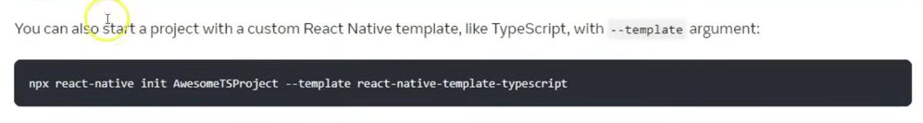
(Old)
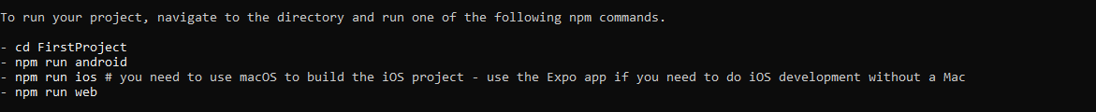
TO run your app type npm run androids
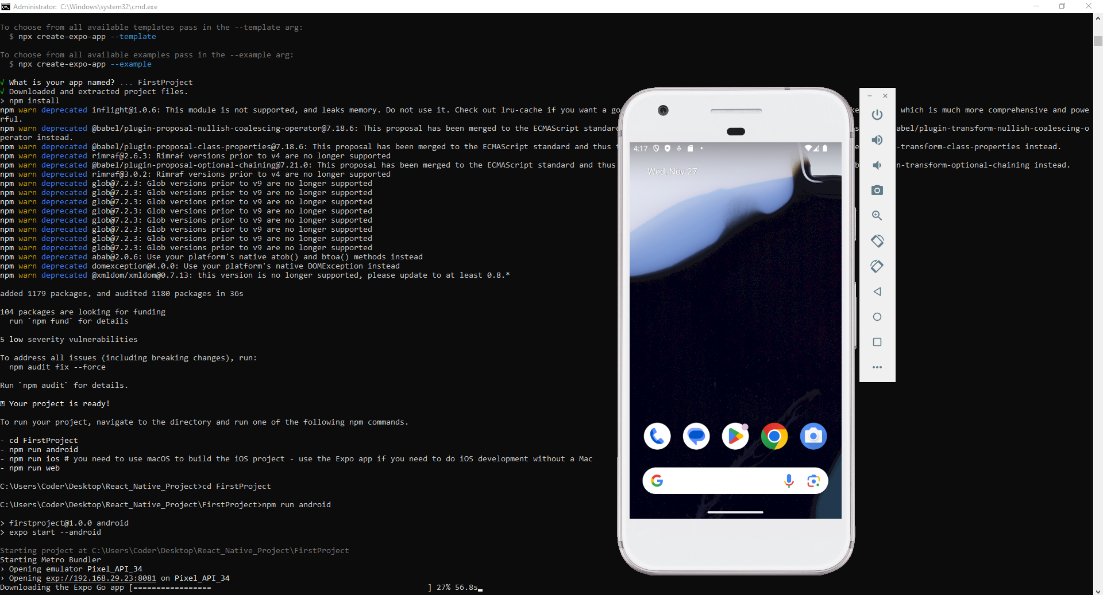
Am emulator will be opened to run your app and in that emulator aand then EXPO
Now your expo app is installed in your emulator
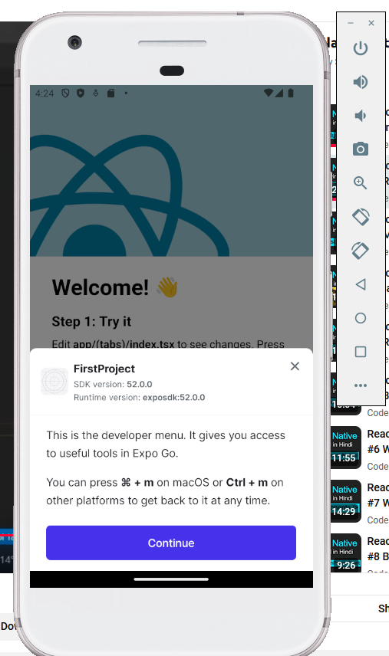
clickk on continue button now your app will be shown to your Now if you open your created project in VS code and then edit it then you can see the chenges in your app when you save the dited file. It contains auto refresh which older version of React native did not have
Now inside the app > (tabs) foldercontains your app design and logic
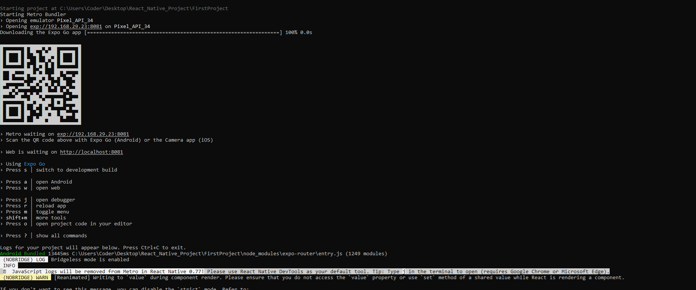

CLI

npx @react-native-community/cli@latest init <Appname>(new version)

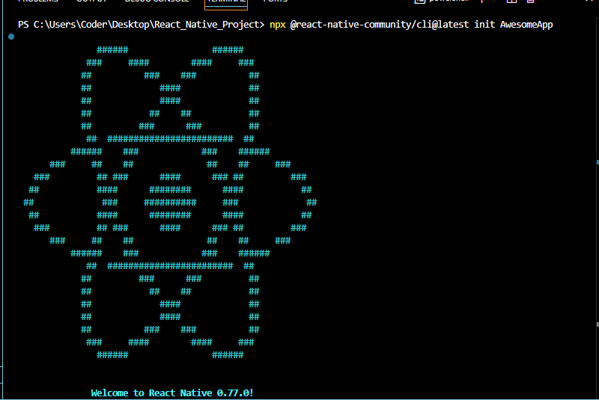

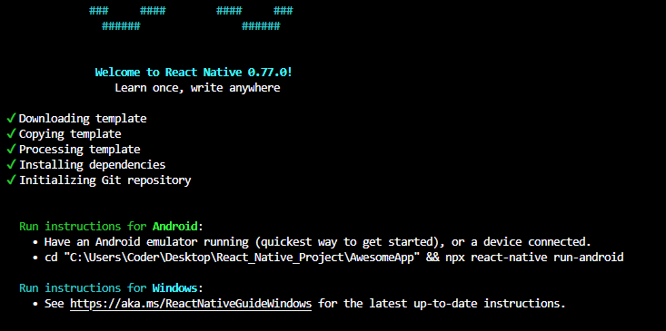
When we create our first logic then there are chances of occurance of errors so if error come then we will see it but according to the teacher if we have followed our steps perfectly then the error should not arise
So no problem arises and our application is also initialised .Now we need
__________________________________CLI Documentation______________________________
To see all about CLI click on get started as marked below after reaching react native website Home Page
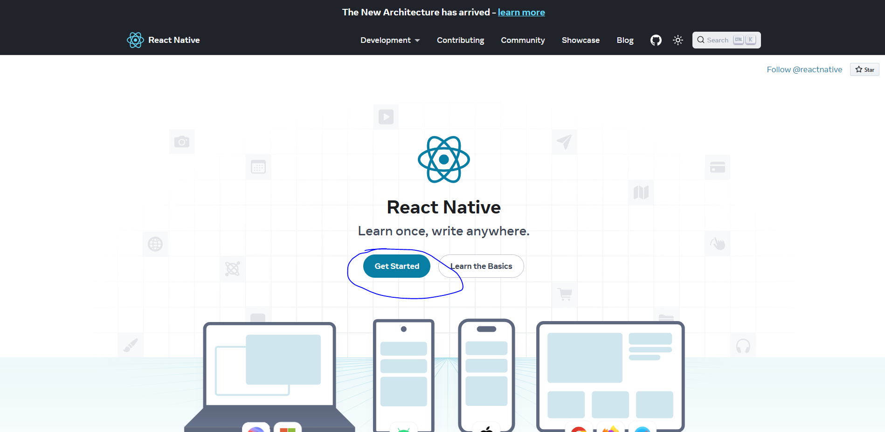
Now below page will be shown Now click on the marked below to expand it
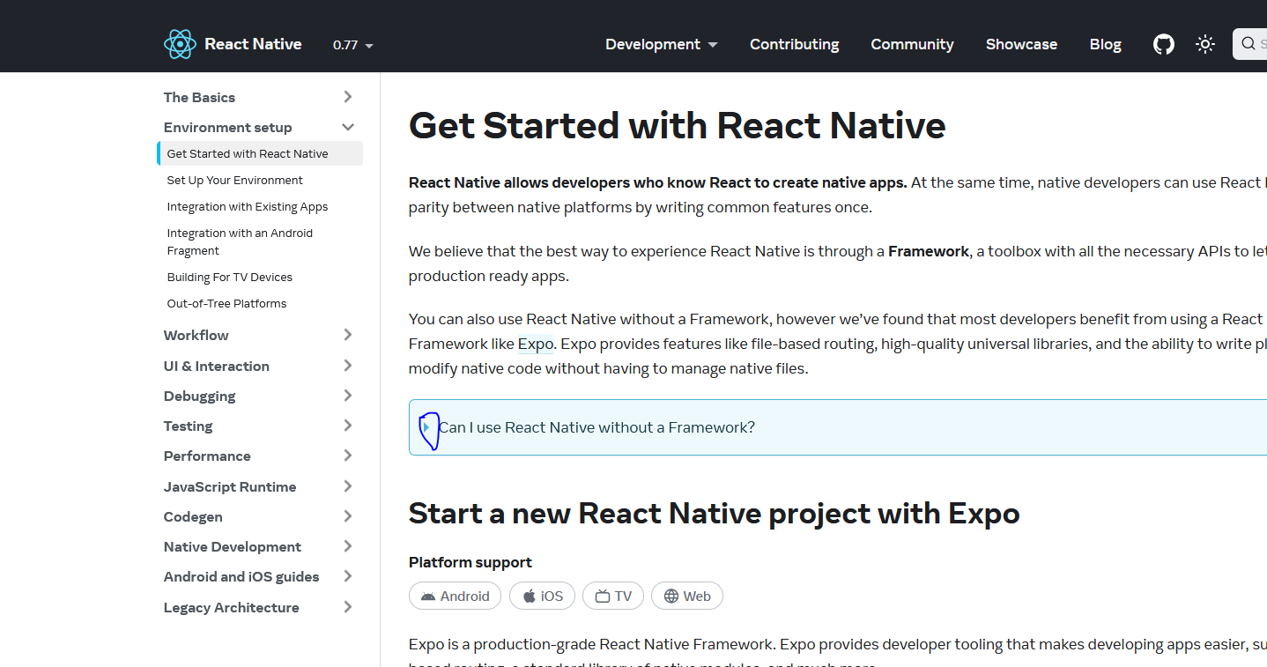
Now after exapnding click on get Started without a framework as marked below

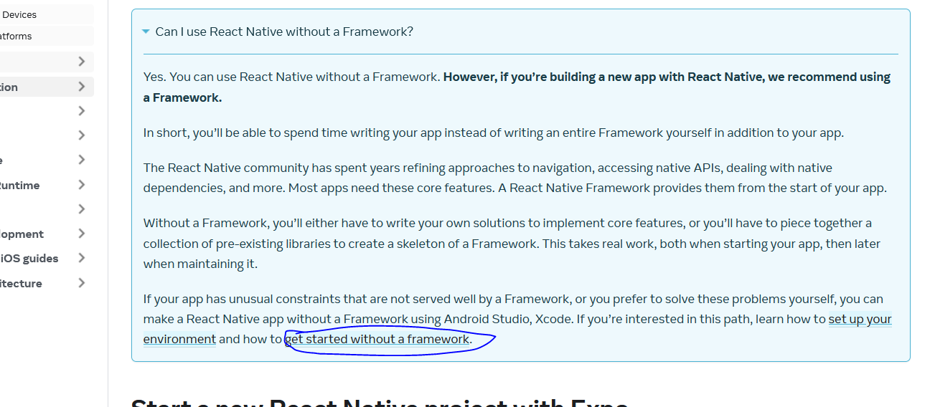
Now in new page you can see all about How to create CLI project

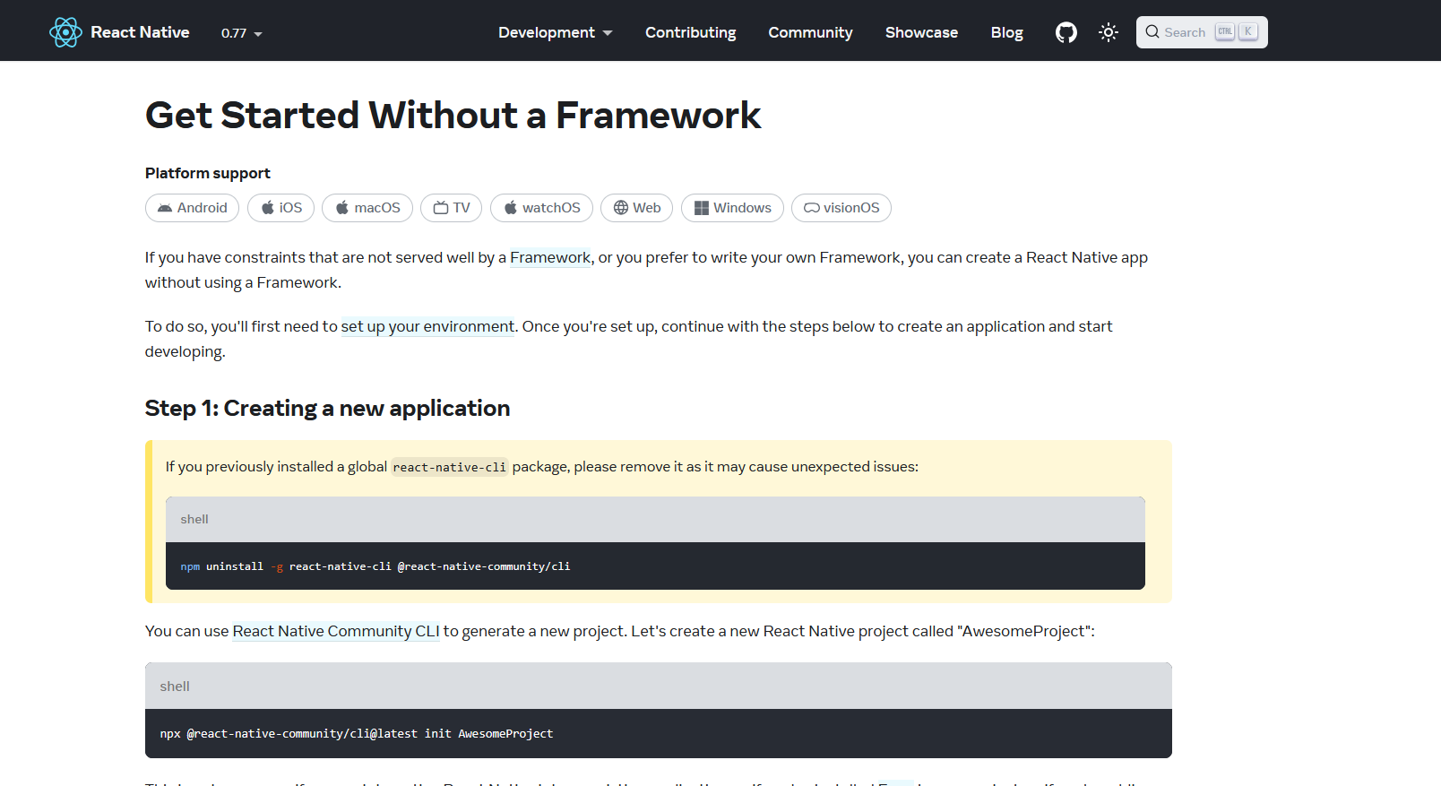
________________________________________________________________________________

Now go inside the folder where your project is with the help of cd cammand

Note:-
To get a project of a specific version of react native then type the below cammand
npx @react-native-community/cli@X.XX.X init AwesomeProject --version X.XX.X

Now to run your project type the cammand
npm start(To start your server)
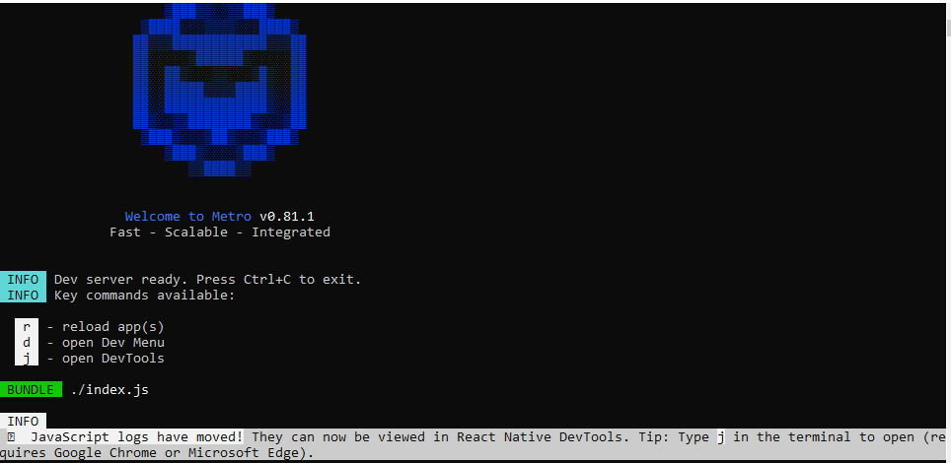
npm run android(in another terminal to start the emulator and run the app)
or
npx react-native run android
there are high chances that the error can occur here
the error can be path was not set properly or is there aany problem in environment variable or NDK is defected There are 90 percent chances that the code wil give some error
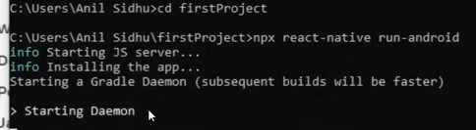
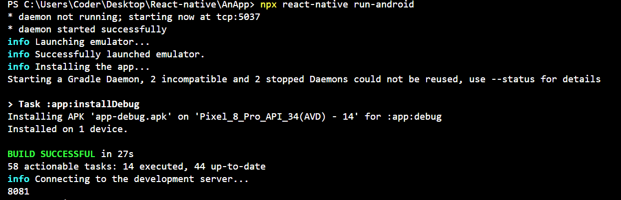
If you reach above then the chances are more less that a problem will arise
Now when the emulator will be opened now you can see the bundling is happening as shown below (maybe building the app)
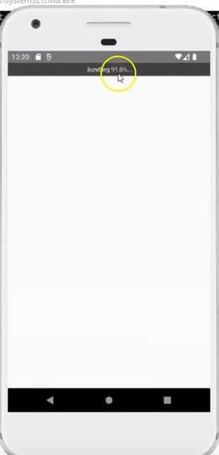
Afet some time your application will start
We will also bring change in teh code to see if it is working perfectly or not
We will see the file structure later

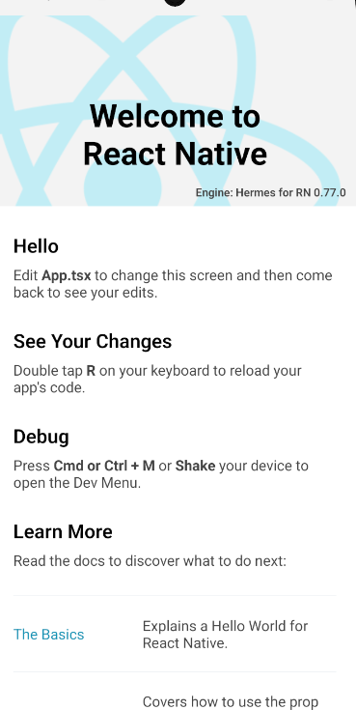
Noww you can see above the output in the emulator
Now we go to App.tsx
and now in app.tsx
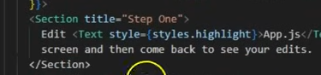
we set the title attribute of section tag from Step One to Like
and in place of Edit we replce it with Hello
like below
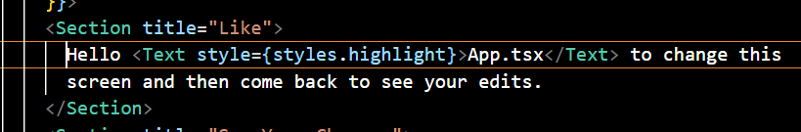
Now the output will be like below
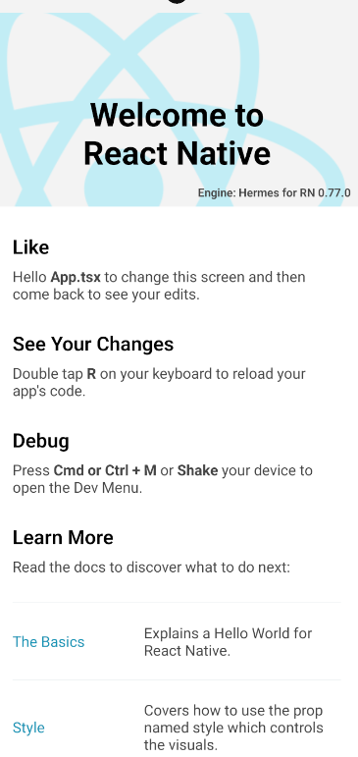
Always remember the output get autorefreshed
means when save the file then the app in emulatorwill be refreshed to show the updated output
In older version it was not like that but in new version it is possible
So our React native is installed

